TOGAF® Template – Solution Building Blocks
Version 2.0
July 2024
Project XXXX
Client YYYY
Note: This document provides a generic template. It may require tailoring to suit a specific client and project situation.
Document Version History
Version  Number | Version  Date | Revised By | Description | Filename

Contents
1. Purpose of this Document 4
1.1 Building Blocks Process 4
2. Building Blocks 5
2.1 Specific Functionality 5
2.2 Attributes 5
2.3 Performance 5
2.4 Configurability 5
2.5 Drivers and Constraints 5
3. Interfaces 6
3.1 Overview 6
3.2 Interoperability 6
3.3 Dependent Building Blocks 6
3.4 Required Solution Building Blocks 6
4. Mapping 7
4.1 SBB Mapping 7
4.2 Relationships Between SBBs and ABBs 7
Tracking Information
Project Name | Project XXX
Prepared By |  | Document Version No.
Title | Requirements Impact Assessment | Document Version Date
Reviewed By |  | Review Date
Distribution List
From | Date | Phone/Email

To | Action* | Due Date | Phone//Email
* Action Types: Approve, Review, Inform, File, Action Required, Attend Meeting, Other (please specify)

Purpose of this Document
Solution Building Blocks (SBBs) relate to the Solutions Continuum, and may be either procured or developed.
SBB characteristics are:
- Define what products and components will implement the functionality
- Define the implementation
- Fulfill business requirements
- Be product or vendor-aware

Building Blocks Process
The process of building block definition takes place gradually as the TOGAF® Architecture Development Method (ADM) is followed, mainly in Phases A, B, C, and D. It is an evolutionary and iterative process because as definition proceeds, detailed information about the functionality required, the constraints imposed on the architecture, and the availability of products may affect the choice and the content of building blocks.
The key phases and steps of the ADM at which building blocks are evolved and specified are summarized in the following figure. The major work in these steps consists of identifying the ABBs required to meet the business goals and objectives. The selected set of ABBs is then refined in an iterative process to arrive at a set of SBBs which can either be bought off-the-shelf or custom developed.
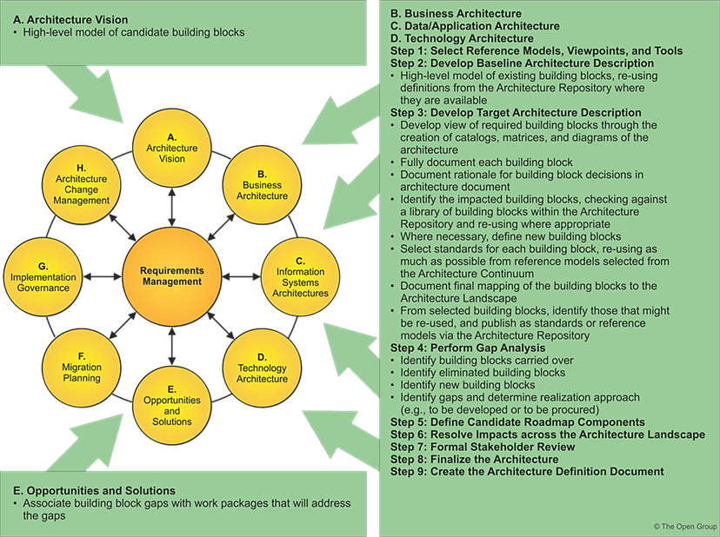

Building Blocks
The purpose of this section is to outline specific functionality and attributes: semantic, unambiguous, including security capability and manageability.

Specific Functionality

Attributes
Specifications of attributes shared across the environment (not to be confused with functionality) such as security, manageability, localizability, scalability.

Performance

Configurability

Drivers and Constraints
Design drivers and constraints, including the physical architecture.

Interfaces
Interfaces: chosen set, supplied.

Overview

Interoperability
Interoperability and relationship with other building blocks.

Dependent Building Blocks
Describe dependent building blocks with required functionality and named user interfaces.

Required Solution Building Blocks
Required SBBs used with required functionality and names of the interfaces used.

Mapping

SBB Mapping
The purpose of this section is to describe mapping from the SBBs to the IT topology and operational policies.
Mandatory/optional: This section is mandatory.

Relationships Between SBBs and ABBs
The purpose of this section is to describe relationships between SBBs and ABBs.
Mandatory/optional: This section is mandatory.

